**Laravel Sail (WSL2) With Docker.**

**Docker** is the light weight virtual machine. It packages up code and all dependencies as a “container”.

**Laravel Sail** was introduced in 2020, Dec. Laravel Sail is a light-weight command-line interface for interacting with Laravel’s default Docker development environment. Sail provides a great starting point for building a Laravel application using PHP, MySQL, and Redis without requiring prior Docker experience

**WSL** stands for Windows Subsystem for Linux, it allows developers to run Linux environments directly on Windows without any “real” hosted VM. WSL 2 is a major overhaul and provides the benefits of WSL 1 with better file IO performance (20x faster). It is not like the traditional VM which may be slow to boot up, large resource overhead, and fully isolated.

**1) Simplified Install (Windows 11 / Windows 10 latest)**

On command window with administrator privileges, run  
“wsl –install”  
With a restart, WSL will be ready to Use.  
if not use this link   
<https://support.microsoft.com/en-us/topic/july-29-2021-kb5004296-os-builds-19041-1151-19042-1151-and-19043-1151-preview-6aba536a-6ed2-41cb-bc3d-3980e8693cc4>

or

**2) Manual Install(Windows 10)**

1. **Enable WSL**  
   Open a command window with administrator privileges then run  
   “ dism.exe /online /enable-feature /featurename:Microsoft-Windows-Subsystem-Linux /all /norestart ”
2. **Enable Virtual Machine feature**  
   WSL 2: dism.exe /online /enable-feature /featurename:VirtualMachinePlatform /all /norestart
3. **Download the Linux kernel update package**<https://wslstorestorage.blob.core.windows.net/wslblob/wsl_update_x64.msi>
4. **Set WSL 2 as your default version  
   “ wsl --set-default-version 2 “**
5. **Install Ubuntu**

* Open the Microsoft Store and then search & select Ubuntu.
* From the distribution’s page, select “Get” then select “Install”
* Click “Launch” when it is ready
* Create your username and password for your Ubuntu

1. **Use “** wsl --list –verbose **” to verify your installation**
2. **Install Docker**<https://docs.docker.com/desktop/windows/install/>
3. **Install**  
   Follow the installation wizard to install the Docker Desktop. If your WSL 2 is configured properly, it should prompt you to enable WSL 2 during installation.  
    if notification comes install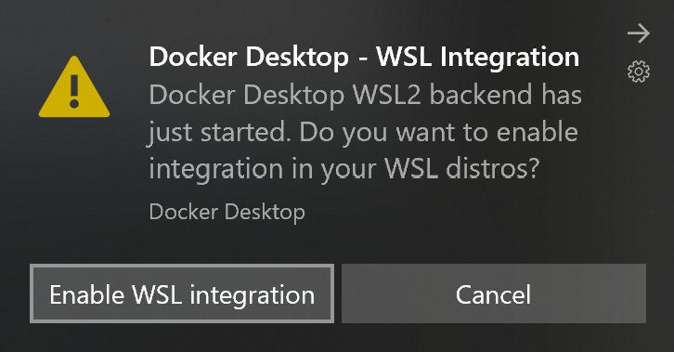  
    In Docker menu, select Settings > General : Make sure WSL 2 is enabled…...   
   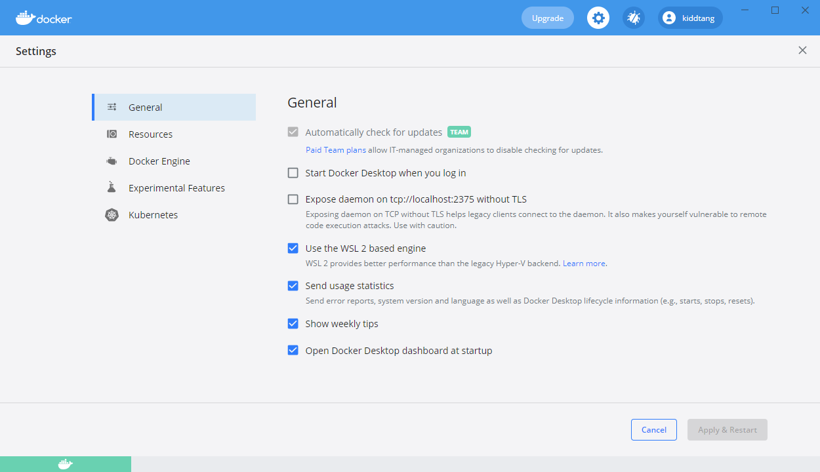
4. **Configure WSL Integration**Turn on Ubuntu/Linux from(select Settings > Resources > WSL Integration)  
   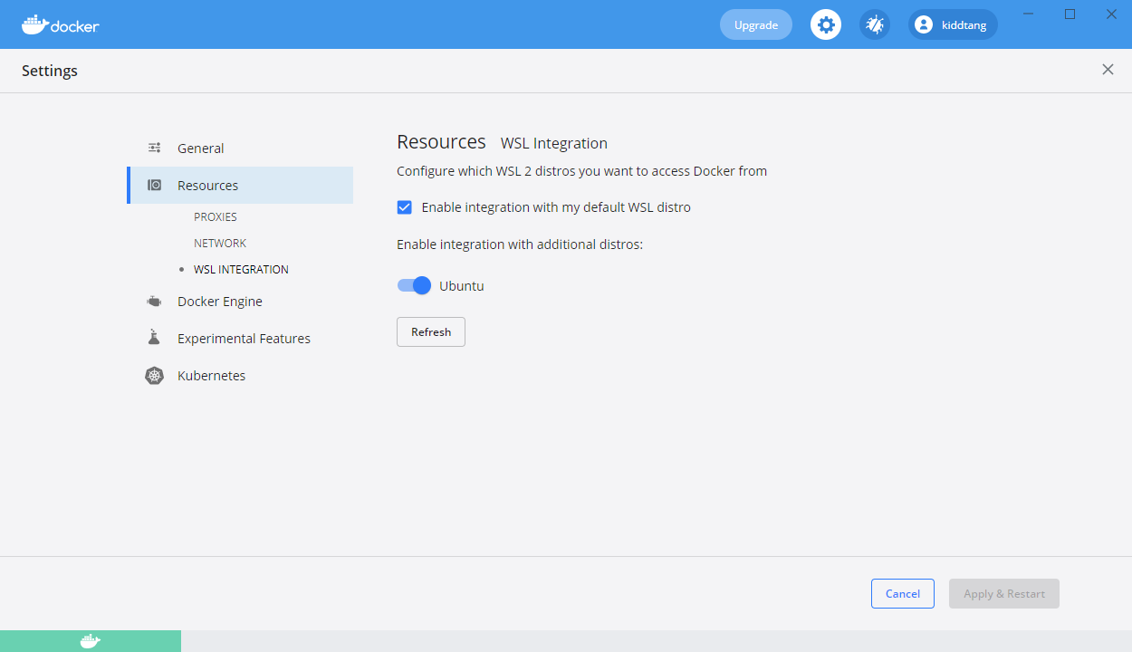
5. **Install PowerShell from Microsoft Store.**

**Lets Sail**

1. Open Powershell:  
   see a option menu click here and select ubuntu.
2. Press “ls” to see directory
3. Create Folder there ”mkdir foldername”
4. Enter into folder by “cd foldername”
5. Install Laravel using “curl -s <https://laravel.build/newapp> | bash”
6. After that enter to that directory using “cd newapp”. If you are not sure about your directory type “ls”to see directories you have.
7. Then Type “./vendor/bin/sail up”

If you encounter any issue, your Antivirus software might be the culprit. Please make the exclusion for the path “C:\ProgramData\DockerDesktop\vm-data\” .  
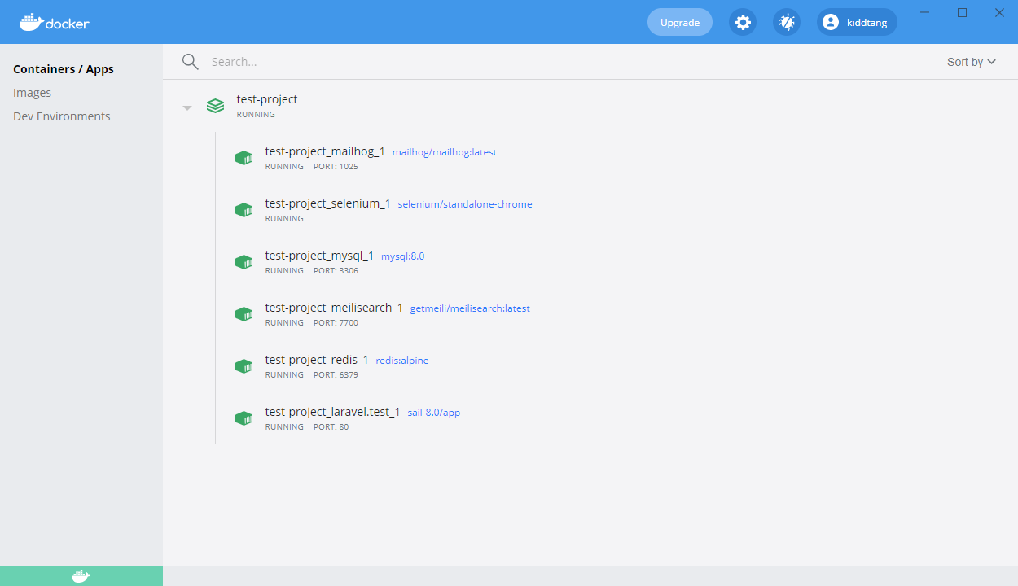

**Run Project on Chrome(any browser):**  
Once the container has been started, you can go to http://localhost for accessing your brand new Laravel project.

**Daily Sail routine**

1. **Start Sail** in detached mode  
   “ ./vendor/bin/sail up -d ”
2. **Stop Sail** in 2 methods
3. “ Ctrl+C ”
4. “./vendor/bin/sail down”

**Alias**

Instead of typing a long path name, configure a Bash alias that allows you to call sail directly  
“ alias sail='bash vendor/bin/sail' ”

**Visual Studio Code**

Make sure you are in your project from command promt(powershell). Then run Code .

Connect with your SQL Management Software(like. heidiSQL) using localhost with the default username is: ‘sail’ and password is: ‘password’.